IoT Lab 1: Temperature & Humidity Sensors

# Overview

Temperature & Humidity sensors solution suitable for multiple applications. In this lab, you are supposed to get an interactive dashboard with the ability to observe real-time data.

# Requirements

Design and implement an IoT dashboard that displays temperature and humidity in real time.

# Hardware:

* ESP32 or ESP32 S3 Development board.
* DHT20 or DHT11 temperature and humidity sensors.
* Connectors.

# Technical Risks:

# Test Plan

### Test Cases:

* Connection test.

### Approach

* Monitor the temperature value displayed on the dashboard. Then, attempt to change the temperature reading by using your breath or finger. Observe any changes in the displayed value.

# Questions

* List some technical specifications of your temperature and humidity monitoring IoT solution.
* **Microcontroller:** ESP32-S3
* **Sensors:** DHT20 (for temperature & humidity)
* **Connectivity:** Wi-Fi (2.4 GHz)
* **Power Supply:** 5V USB / Li-ion battery with power management

**Data Storage:** Cloud (ThingsBoard)

* **Firmware:** PlatformIO
* **Communication:** MQTT
* **Cloud Integration:** ThingsBoard
* Write instructions and notable points when deploying the solutions.

Connect **DHT20** sensor to **ESP32-S3**

Install **PlatformIO**

Configure **Wi-Fi & MQTT settings**

Set up an **MQTT broker(Thingsboard)**

Configure a **dashboard** for real-time data visualization

# Instructions:

* Do a quick test of the development board and development environment by running “hello world” example.
* Run a DHT20 example to read sensor data and print out to the serial monitor to make sure your hardware is working as expected.

# Resources

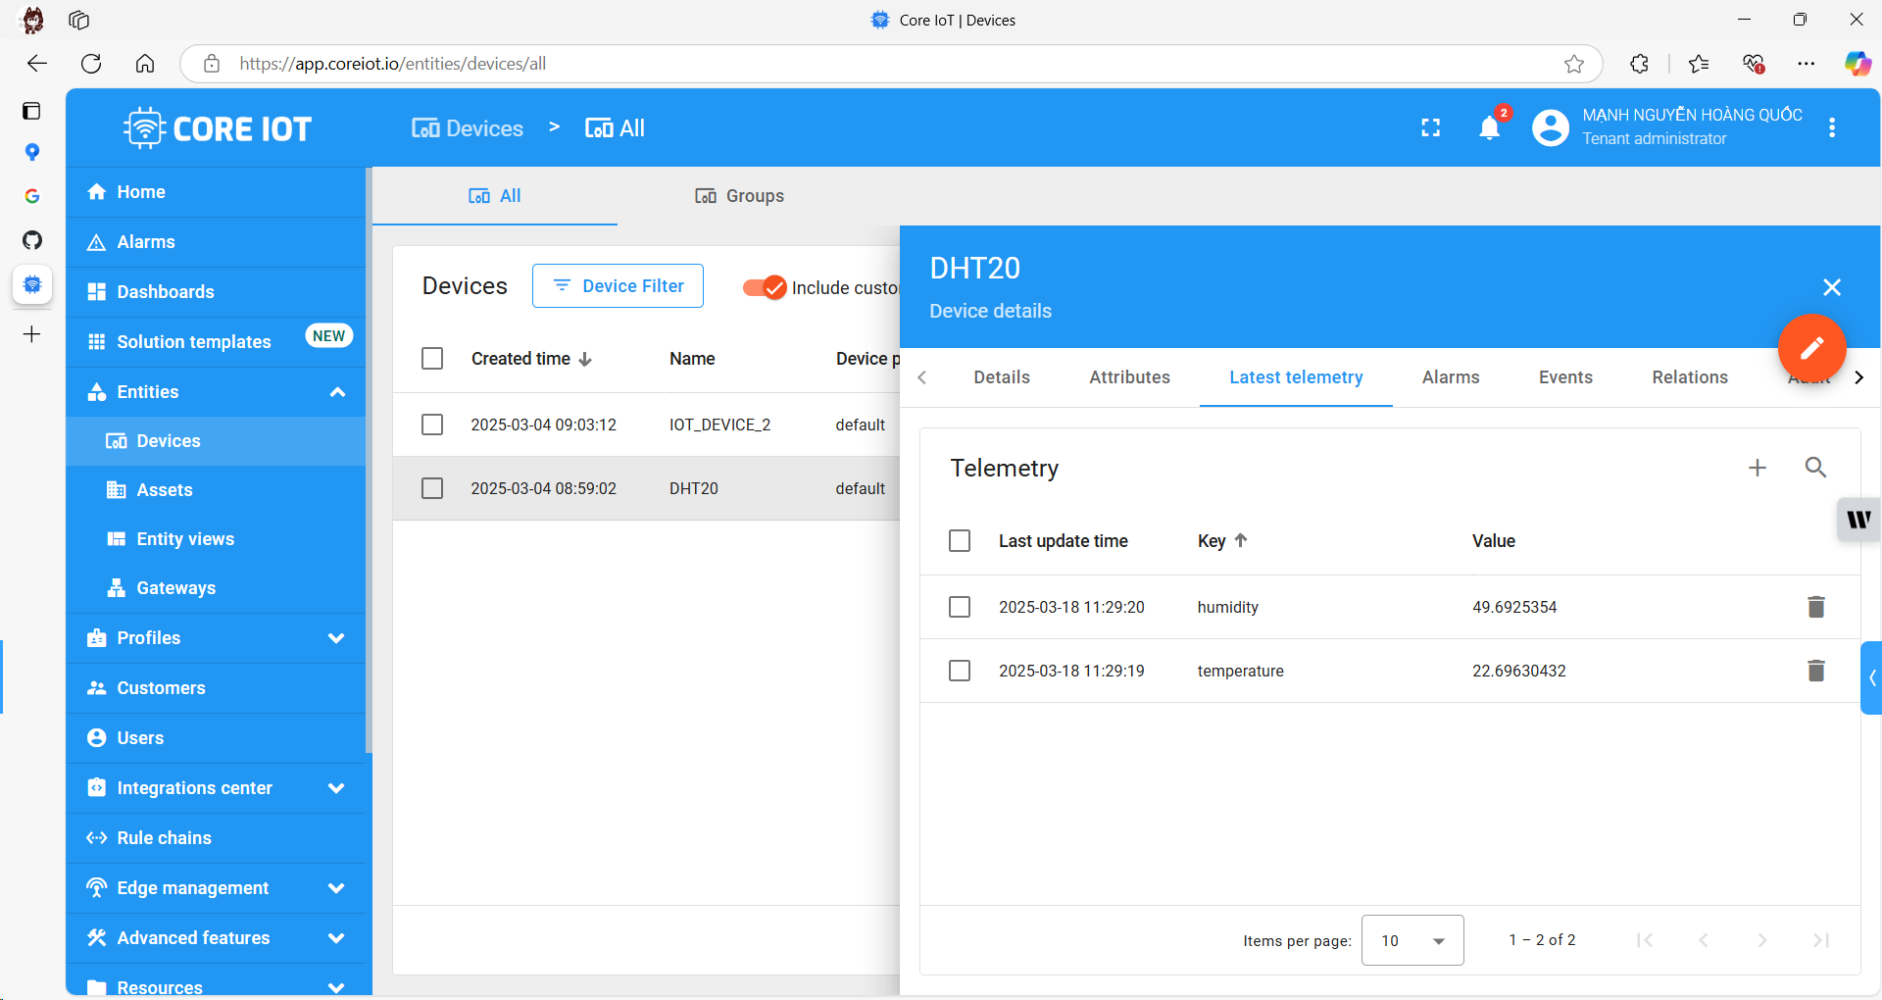

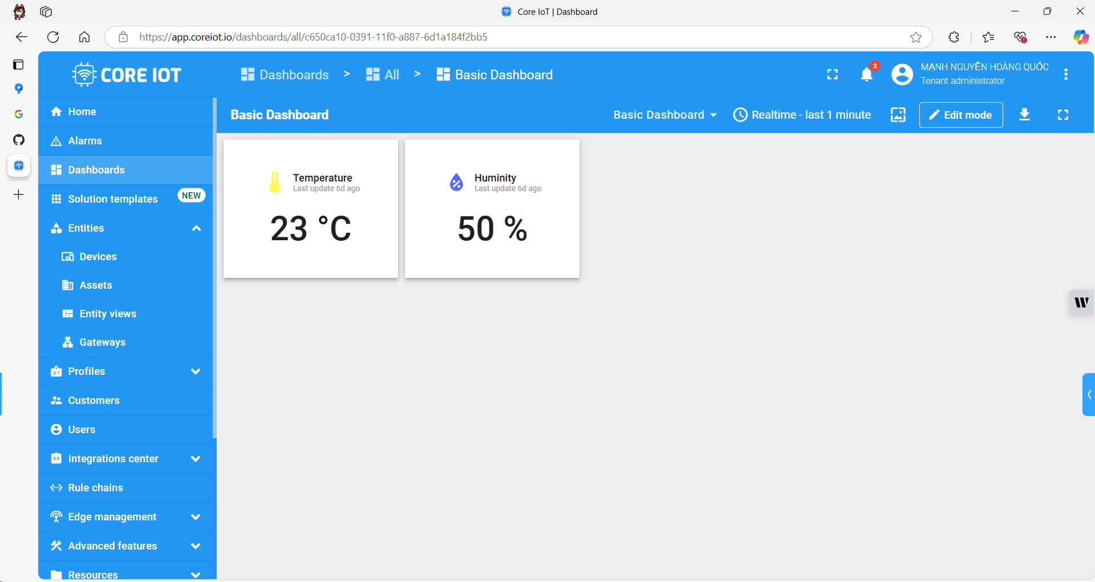

https://github.com/rynastermun/Tempuratur-Humadity